**Superhuman Registration Act Database**

Property of the Strategic Homeland Intervention and Enforcement Logistics Division   
(S.H.I.E.L.D.)

Report Issued:

December 8, 2016

Report Issuer:

Agent Nicholas Bradford, **Clearance Level 5**

Report Requisitioned by:

Director Fury, **Clearance Level 10;**

Commander Alan Labouseur, **Clearance Level 8**

Table of Contents

Executive Summary 1

Overview 1

Objectives 1

Entity relationship diagram 2

Tables 3

MetaHumans 3

Types 4

Origins 5

Levels 6

Abilities 7

Activity 8

Registration 9

States 10

Addresses 11

Teams 12

Locations 13

EventNames 14

Events 15

Convicted 16

Views 17

AccessMetaData 17

PowerInventory 18

ConvictCatalog 19

Reports 20

Meta-City Population 20

Find Events 21

Origin Power Levels 22

Stored Procedures 23

LocateMetaOrigin() 23

LocateMetaAbility() 24

Security 25

Level 5 Agent 25

Level 6 Agent 25

Level 7 Agents 25

Level 8 Agents 26

Level 9 Agents 26

Level 10 Agents 26

# Executive Summary

## Overview

Since the 1940s the United States government and the world at large has been aware of beings known as ‘Super humans’ or Metas. Seventy-five years later, the world has been ravaged by these Metas who have done nothing but put the lives of average men and women in danger as they continue unchecked and unbeholden to any man, nation, or creed but their own.

In 2007 a group of Metas calling themselves ‘The New Warriors’ were in the middle of broadcasting a reality television show in which they hunted down other Metas. There was an altercation when a Meta calling himself Nitro let loose a 3kiloton nuclear blast that leveled Stamford, CT. The resulting political and social backlash on the Metas was unprecedented and after a ‘Civil War’ between two conflicting factions of Metas, the surviving members agreed to be submitted to an act of Congress: The Super Human Registration Act.

The Strategic Homeland Intervention Enforcement and Logistics Division (S.H.I.E.L.D.) was commissioned to develop, house, and manage a database for the consolidation of all information gathered pertaining to the Metahumans.

## Objectives

S.H.I.E.L.D commissioned this Database to monitor, study, and deploy registered and unregistered Metas. This database is top secret and therefore only the highest clearance of S.H.I.E.L.D agent will be allowed access. This is because of the sensitive information contained in the database such as the secret identities of several hundred Meta humans and their constantly updated locations.

This document will be a guiding document for different applications available in the database to access the information. It will also include technical specifications as to access to different aspects of the database such as permissions, adding new Metas that S.H.I.E.L.D has tracked or have registered with the Superhuman Registration Act (SHRA).

# Entity relationship diagram

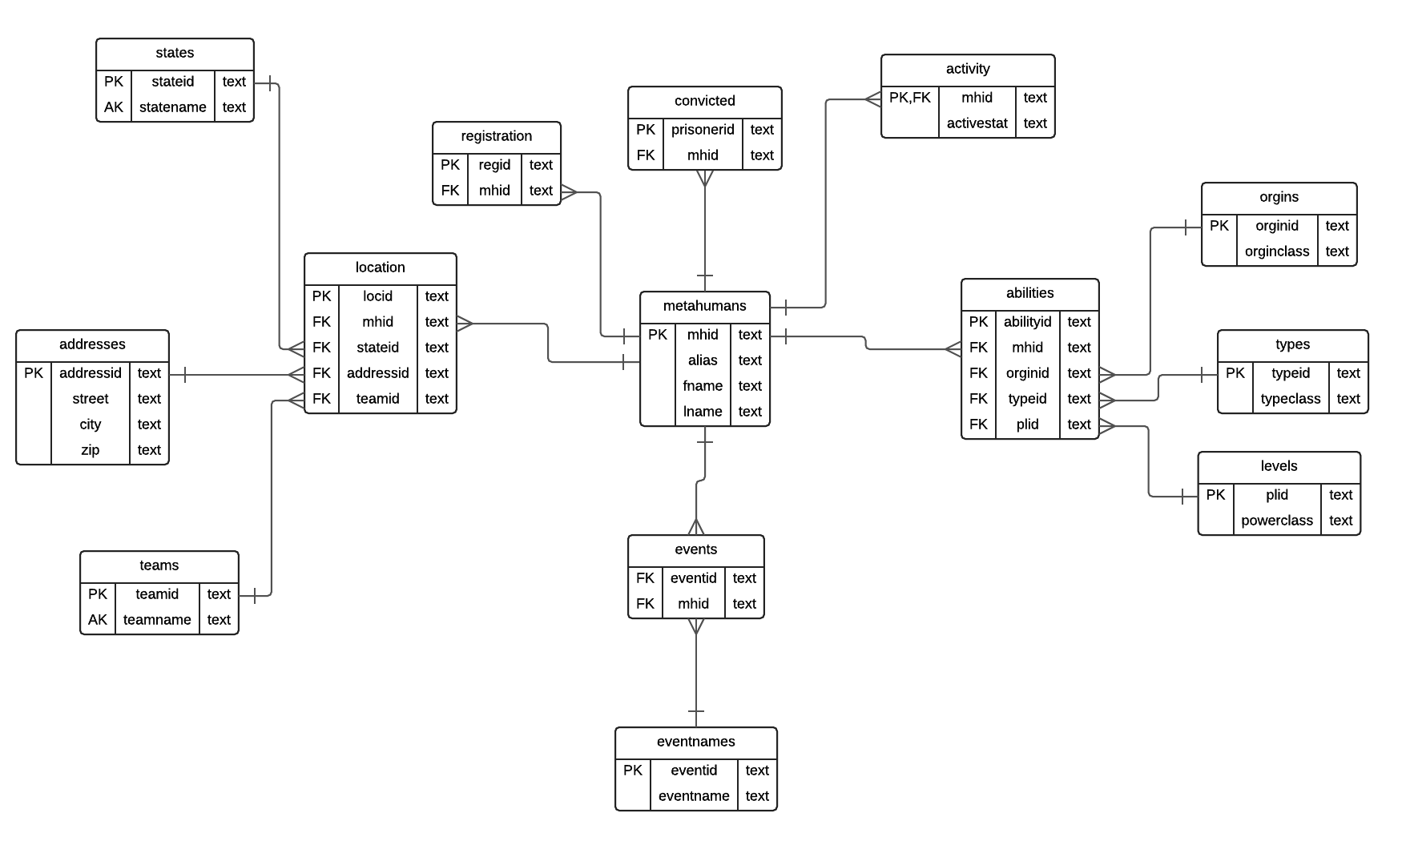

# Tables

## MetaHumans

### Purpose

The main table of the Database, housing the alias, real first and last name, and MetaHuman Identification number of each Meta.

*FROM THE DESK OF DIRECTOR FURY: The MHID should not be confused with the Registration ID that is designated based on the SHRA. That is a number used for the Registration Database used by the U.S. Government, while the MHID is a number that has been used in S.H.I.E.L.D reports for decades.*

### Create Statement

CREATE TABLE METAHUMANS(

MHID TEXT,

alias TEXT,

fName TEXT,

lName TEXT,

PRIMARY KEY (MHID)

);

### Functional Dependecies

MHID → Alias, fName, lName

### Sample Data

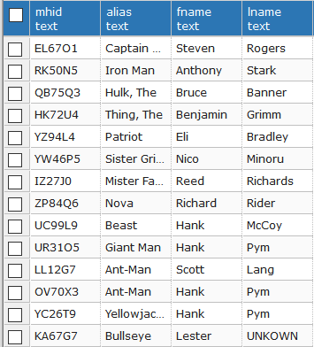

## Types

### Purpose

This table of the database monitors the Type of Ability owned by a Meta {Mind Control, Super Strength, etc.}

### Create Statement

CREATE TABLE TYPES(

TypeID TEXT,

TypeClass TEXT NOT NULL,

PRIMARY KEY (TypeID)

);

### Functional Dependecies

TypeID → TypeClass

### Sample Data

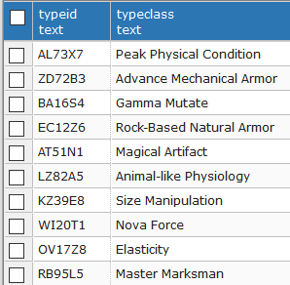

## OrIgins

### Purpose

This table of the database monitors the Origin of Ability owned by a {Tech, Mutant, Inhuman, Bio-Advancement, etc.}

### Create Statement

CREATE TABLE ORIGINS (

OriginID TEXT,

OriginClass TEXT NOT NULL,

PRIMARY KEY (OriginID)

);

### Functional Dependecies

OriginID → OriginClass

### Sample Data

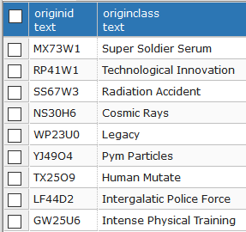

## Levels

### Purpose

This table of the database designates power levels of metas ranging from the most powerful Omega class, down to Gamma class.

### Create Statement

CREATE TABLE LEVELS(

PLID TEXT,

PowerClass TEXT NOT NULL,

PRIMARY KEY (PLID)

);

### Functional Dependecies

PLID → PowerClass

### Sample Data

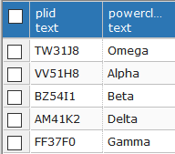

## Abilities

### Purpose

The table is used to consolidate all ability information about a Meta: Ability, Origin of Power, and Power Level Classification. This is used for the tracking of Meta’s abilities and their frequency.

Create Statement

CREATE TABLE LEVELS(

AbilityID TEXT,

MHID TEXT REFERENCES METAHUMANS (MHID),

OriginID TEXT REFERENCES ORIGINS (OriginID),

TypeID TEXT REFERENCES TYPES (TypeID),

PLID TEXT REFERENCES LEVELS (PLID),

PRIMARY KEY (AbilityID)

);

### Functional Dependecies

AbilityID → MHID, OriginID, TypeID, PLID

### Sample Data

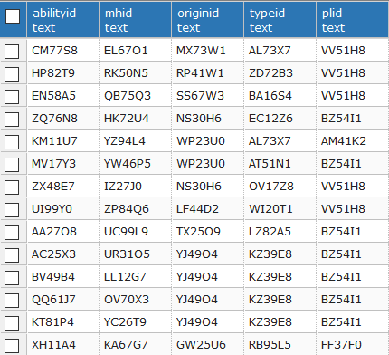

## Activity

### Purpose

The table is used to monitor activity of Metas {Inactive, Active, Retired, Deceased, Missing}

***NOTE:*** *This table uses an enumerated data-type ‘actstat’ which takes the afore-stated inputs.*

### Create Statement

CREATE TABLE ACTIVITY(

MHID TEXT REFERENCES METAHUMANS (MHID),

ActiveStat actstat,

PRIMARY KEY (MHID)

);

### Functional Dependecies

MHID → ActiveStat

### Sample Data

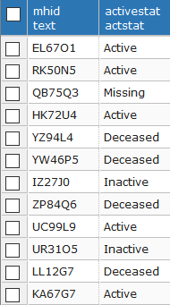

## Registration

### Purpose

The registration identification number of all registered Metas. Registered Metas can be farmed out to other agencies and commissioned to the Initiative.

### Create Statement

CREATE TABLE REGISTRATION (

RegID TEXT,

MHID TEXT REFERENCES METAHUMANS(MHID),

PRIMARY KEY (RegID)

);

### Functional Dependecies

RegID → MHID

### Sample Data

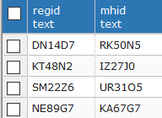

## States

### Purpose

The table is used to identify the State of Operations that the Meta is currently residing in.

### Create Statement

CREATE TABLE STATES(

StateID TEXT,

StateName TEXT NOT NULL UNIQUE,

PRIMARY KEY (StateID)

);

### Functional Dependecies

StateID → StateName

### Sample Data

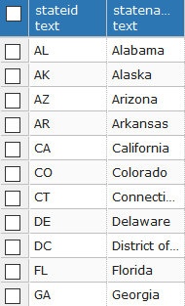

## Addresses

### Purpose

The table is used to identify the home address of any meta that is either being tracked by S.H.I.E.L.D or is registered with the SHRA

### Create Statement

CREATE TABLE ADDRESSES(

AddressID TEXT,

Street TEXT ,

City TEXT NOT NULL,

Zip TEXT,

PRIMARY KEY (AddressID)

);

### Functional Dependecies

AddressID → Street, City, Zip

### Sample Data

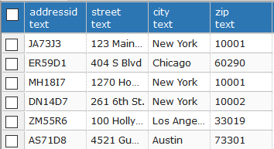

## Teams

### Purpose

The table is used to identify Meta-Team membership. This is also necessary for the Fifty-State-Initative and designating full teams of six Metas for each state.

### Create Statement

CREATE TABLE TEAMS(

TeamID TEXT,

TeamName TEXT NOT NULL UNIQUE,

PRIMARY KEY (TeamID)

);

### Functional Dependecies

TeamID → TeamName

### Sample Data

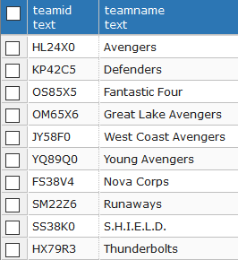

## Location

### Purpose

The table is used to consolidate all location information about a Meta: State of Operation, Home Adress, and Team Membership. This is used for the physical tracking of Metas wherever applicable.

### Create Statement

CREATE TABLE LOCATION (

LocID TEXT,

MHID TEXT REFERENCES METAHUMANS(MHID) NOT NULL,

StateID TEXT REFERENCES STATES(StateID) NOT NULL,

AddressID TEXT REFERENCES ADDRESSES(AddressID),

TeamID TEXT REFERENCES TEAMS(TeamID),

PRIMARY KEY (LocID)

);

### Functional Dependecies

LocID → MHID, StateID, AddressID, TeamID

### Sample Data

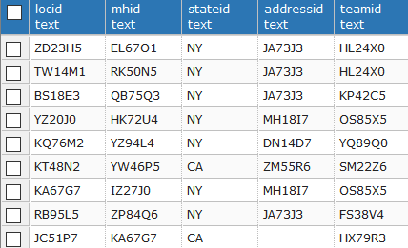

## EventNames

### Purpose

The table is used to catalog universe wide events to better understand and collect information about them.

### Create Statement

CREATE TABLE EVENTNAMES (

EventId TEXT REFERENCES EVENTNAMES(EventId),

EventName TEXT NOT NULL,

PRIMARY KEY (EventID)

);

### Functional Dependecies

EventID → EventName

### Sample Data

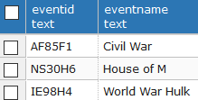

## Events

### Purpose

The table is used to connect universe wide events that have occurred to check for correlations between them.

*FROM THE DESK OF DIRECTOR FURY: When in doubt, look for a Maximoff. They are always behind something screwy going on.*

### Create Statement

CREATE TABLE EVENTS (

EventId TEXT REFERENCES EVENTNAMES(EventId),

MHID TEXT REFERENCES METAHUMANS(MHID)

);

### Functional Dependecies

EventID,MHID →

### Sample Data

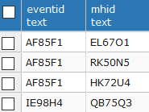

## Convicted

### Purpose

The table is used to catalog Metas with criminal records and keep track of Metas involved in the Thurderbolt program or who must be brought in for questioning.

### Create Statement

CREATE TABLE CONVICTED (

PrisonerID TEXT ,

MHID TEXT REFERENCES METAHUMANS(MHID),

PRIMARY KEY (PrisonerID)

);

### Functional Dependecies

PrisonerID → MHID

### Sample Data



# Views

## AccessMetaData

### Purpose

The most basic function of the SHRA-DB is to gather rudimentary information on Metas such as their Alias, their powers, and there real name. Instead of requiring an unwieldy query every time this simple information is required, the database houses a view called “AccessMetaData” which when Selected gives all this information

### Create Statement

CREATE VIEW AccessMetaData AS

SELECT m.mhid, m.alias, m.fname, m.lname, t.typeclass, o.originclass, l.powerclass

FROM METAHUMANS m

INNER JOIN ABILITIES a ON m.MHID = a.MHID

INNER JOIN TYPES t ON a.typeId = t.typeId

INNER JOIN ORIGINS o ON a.originId = o.originId

INNER JOIN LEVELS l ON a.plid = l.plid

ORDER BY MHID ASC;

### Sample Data

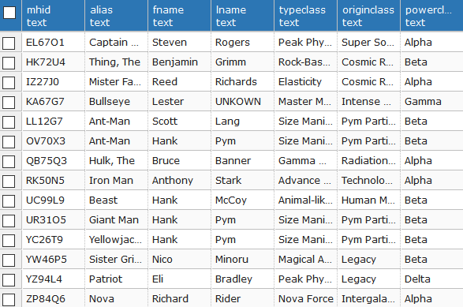

## PowerInventory

### Purpose

To further catalog the Meta population, the database also keeps a real-time count of the number of active Metas with any given ability and how they received their ability. There are no names attached to this view, as it is simply designed for census purposes, gauging the frequency of given abilities currently active. This can be combined with the LocateMetaAbility() function to search for specific individuals based on their powerset.

### Create Statement

CREATE VIEW PowerInventory AS

SELECT COUNT(t.typeID), t.typeclass, o.originclass

FROM ABILITIES a

INNER JOIN TYPES t ON a.typeId = t.typeId

INNER JOIN ORIGINS o ON a.originId = o.originId

INNER JOIN ACTIVITY ac ON a.MHID = ac.MHID

WHERE ac.activestat = 'Active'

GROUP BY t.typeclass, o.originclass;

### Sample Data

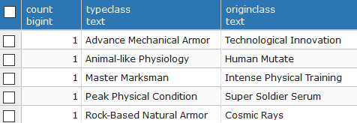

## ConvictCatalog

### Purpose

There are several Metas in the world who have checkered pasts, but there are an even greater number who refuse to use their abilities for the common good. As part of S.H.I.E.L.D’s mission, we attempt to rehabilitate these Metas when we can, and lock them up when we can’t. A useful view to have, in this vein, is to be able to track any Metas who have criminal records and are taking part in our Thunderbolt program.

The Thunderbolts are troubled Metas who we have extended the option for them to work on the side of the law in exchange for a commuted prison sentence. To be eligible for the Thunderbolt Program, the Meta must have a Criminal Record (shown by a PrisonerID) and Registered with the SHRA (shown by a RegID)

### Create Statement

CREATE VIEW ConvictCatalog AS

SELECT m.mhid,m.alias

From METAHUMANS m

INNER JOIN REGISTRATION r ON m.MHID = r.MHID

INNER JOIN CONVICTED cr ON m.MHID = cr.MHID

INNER JOIN LOCATION l ON m.MHID = l.MHID

INNER JOIN TEAMS t ON l.teamid = t.teamid

ORDER BY MHID ASC;

### Sample Data

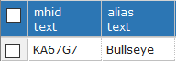

# Reports

## Meta-City Population

### Purpose

S.H.I.E.L.D’s mission is to monitor and control the proliferation of Weapons of Mass Destruction across the globe and one such group of weapons is the Meta community. As such, the SHRA-DB can be used to keep track of the number of Metas in Cities across the nation.

### Create Statement

SELECT COUNT(l.MHID) AS "Population", a.City, st.StateName

FROM LOCATION l

INNER JOIN ADDRESSES a ON l.addressID = a.addressID

INNER JOIN STATES st ON l.StateID = st.StateID

GROUP BY a.City, st.StateName

### Sample Data

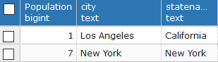

## Find Events

### Purpose

When a universal or worldwide event takes place, it is S.H.I.E.L.D.’s responsibility to act as both Earth’s first line of Defense and its Janitors. As such, it is important for S.H.I.E.L.D to keep track of all major events that happen in the universe and catalog those metas that were involved.

### Create Statement

SELECT m.alias, en.eventName

FROM METAHUMANS m

INNER JOIN EVENTS ev on m.MHID = ev.MHID

INNER JOIN EVENTNAMES en on ev.EventID = en.EventID

ORDER BY eventName ASC;

### Sample Data

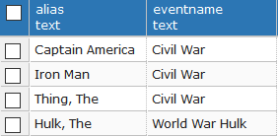

## Origin Power Levels

### Purpose

Metas are a relatively new species in the grand scheme of scientific discovery, and as such we have very limited information on what powers become the most powerful versus others. The SHRA-DB allows us to track those powers and compare them to the power levels our experts have assigned to the Metas. This allows us to further study the meta-volution.

### Create Statement

SELECT DISTINCT t.typeclass, l.PowerClass

FROM abilities a

INNER JOIN TYPES t ON a.typeId = t.typeId

INNER JOIN LEVELS l ON a.PLID = l.PLID

ORDER BY l.powerclass,t.typeclass ASC;

### Sample Data

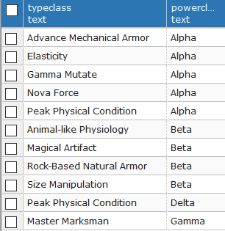

# Stored Procedures

## LocateMetaOrigin()

### Purpose

The ability to research a Metahumans origin is an incredibly useful tool. Being able to catalog how many Human Mutate (Mutants) are registered versus how many Super Soldiers. The Function takes the parameter of one of Meta origins and returns the name of the Alias of the Meta and their ability.

### Create Statement

CREATE OR REPLACE FUNCTION locateMetaorigin (ans text)

Returns Table ("Alias" text, "State" text, "Ability" text) AS $$

BEGIN

Return QUERY

Select m.alias , st.stateName, t.typeclass

From metahumans m

INNER JOIN abilities a ON m.MHID = a.MHID

INNER JOIN types t ON a.typeId = t.typeId

INNER JOIN ORIGINS o ON a.originId = o.originId

INNER JOIN LOCATION l ON m.MHID = l.MHID

INNER JOIN STATES st ON l.StateID = st.stateID

Where o.originclass = ans;

END;

$$ LANGUAGE plpgsql;

### Select Statement

SELECT *

FROM locateMetaOrigin(*variable*);

### Sample Data

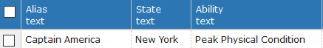

*\*This Sample Data is found using the variable ‘Super Soldier Serum’ in the locateMetaOrigin() function.*

## LocateMetaAbility()

### Purpose

The ability to search and obtain a record of all Metas with a particular ability can be incredible useful for an agent-user of the SHRA database. When putting together a strike team that requires specific abilities, the database becomes an indispensable resource.

### Create Statement

CREATE OR REPLACE FUNCTION locateMetaAbility(ans text)

RETURNS TABLE ("Alias" text, "State" text, "Origin" text) AS $$

BEGIN

RETURN QUERY

SELECT m.alias , st.stateName, o.Originclass

FROM metahumans m

INNER JOIN abilities a ON m.MHID = a.MHID

INNER JOIN types t ON a.typeId = t.typeId

INNER JOIN ORIGINS o ON a.originId = o.originId

INNER JOIN LOCATION l ON m.MHID = l.MHID

INNER JOIN STATES st ON l.StateID = st.stateID

WHERE t.typeclass = ans;

END;

$$ LANGUAGE plpgsql;

### Select Statement

SELECT *

FROM locateMetaAbility(*variable*);

### Sample Data

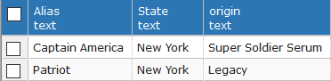

*\*This Sample Data is found using the variable ‘Peak Physical Condition’ in the locateMetaAbility() function.*

# Security

S.H.I.E.L.D prides itself on its hierarchal organization and chain-of-command, and as such, permissions for the database will be handed out based on the internal S.H.I.E.L.D command levels. Since no one below a Scientist will need access to this database without clearance, we will begin at Level 5 and work our way up to Level 10;

## Level 5 Agent

Level Five Agents are scientists and therefore get the Barest minimum information, only being allowed to access the basic Metahuman table.

GRANT SELECT ON metahumans TO LevelFive;

## Level 6 Agent

Level 6 are field operatives and therefore are required to know a bit more about their potential counter-combatants. This means that they are allowed to access information on basic information as well as powers.

GRANT SELECT ON metahumans TO LevelSix;

GRANT SELECT ON abilities TO LevelSix;

GRANT SELECT ON types TO LevelSix;

## Level 7 Agents

Level 7 represent deep cover combat agents and the beginning of high command. Therefore, they are allowed to access information that can be potentially fatal to Metas if it is received by the wrong hands. This information includes where the Meta is based, their origin, and any team affiliations.

GRANT SELECT ON metahumans TO LevelSeven;

GRANT SELECT ON abilities TO LevelSeven;

GRANT SELECT ON types TO LevelSeven;

GRANT SELECT ON origins TO LevelSeven;

GRANT SELECT ON location TO LevelSeven;

GRANT SELECT ON states TO LevelSeven;

GRANT SELECT ON teams TO LevelSeven;

## Level 8 Agents

Level 8 agents receive information to an even greater degree than Level 7, gaining access to Meta home addresses to issue missions, allowing these agents to put together teams for missions.

GRANT SELECT ON metahumans TO LevelEight;

GRANT SELECT ON abilities TO LevelEight;

GRANT SELECT ON types TO LevelEight;

GRANT SELECT ON origins TO LevelEight;

GRANT SELECT ON location TO LevelEight;

GRANT SELECT ON states TO LevelEight;

GRANT SELECT ON teams TO LevelEight;

GRANT SELECT ON addresses TO LevelEight;

## Level 9 Agents

Level 9 represents the second highest rank in S.H.I.E.L.D and as such they receive special permissions to insert, and update the metahumans table aspect of the database. This is to ensure that only the highest level of S.H.I.E.L.D Agent has access to the changing the database in a way that can change the integrity of the data.

GRANT SELECT,INSERT,UPDATE ON metahumans TO LevelEight;

GRANT SELECT ON abilities TO LevelEight;

GRANT SELECT ON types TO LevelEight;

GRANT SELECT ON origins TO LevelEight;

GRANT SELECT ON location TO LevelEight;

GRANT SELECT ON states TO LevelEight;

GRANT SELECT ON teams TO LevelEight;

GRANT SELECT ON addresses TO LevelEight;

## Level 10 Agents

Director Fury is the only publicly known Level 10 agent. The saying in S.H.I.E.L.D. is that even though he is missing an eye, he sees everything. In this vein of idea, Level 10 Agents have complete access to the entire database.

GRANT ALL ON ALL TABLES IN SCHEMA PUBLIC TO LevelTen;

# Implementation

The following notes are on the implementation on the SHRA database.

* Please again note that MHID, PrisonerID, and RegID are not interchangeable. These numbers all reference each other based on different databases that exists in the S.H.I.E.L.D. network.
* The SHRA database is not designed to be used by anyone who does not have code word or level clearance. As such, the permissions for the database limit the data and information received by anyone but the highest Levels of S.H.I.E.L.D agent. In this vein, there are several tables that are completely inaccessible by any agent except agents of the same level as Director Fury
* The database is open enough in its design that it can be added to and edited continuously. As such, there are many options for adding functions, views, and reports at a later date

# Known Problems

Issues arising from this database have been cataloged and are as follows.

* Only Level 9 and Level 10 agents can insert information into metahumans, and only Level 10 can insert data into any other table. In theory once the database is fully operational and the Database administer has surrendered control, there should be no need to insert any information into the majority of tables.
* The *AccessMetaData* view offers technically more information that is advertises to lower level agents. While the information of a Meta’s first and last name should be confidential, it can be easily accessed through this View, but the option of making a string of views to appeal to every niche need was not required.
* The *PowerInventory* view is not succinct in its design. While it does master its intended purpose of showing a catalog of powers and their origins, the reality is that except for a few generic powers such as flight, energy projection, and physiological changes, no power is common enough or have a common enough origin to make this more truly useful. This just insinuates that the *PowerInventory* view is only useful in its conjunction with the *LocateMetaOrigin()* and *LocateMetaAbility()* functions.

# Future Enhancments

While the project is complete in the most basic sense of what it has been commissioned for, the database administrator has offered these suggestions for future enhancements.

* A purpose of the database is to facilitate the proliferation of metahumans into the various meta-groups as part of the Fifty State Initiative. As such, functions to catalog the number of Metas in each team and assign new Metahumans to the groups when their rosters are depleted. To properly design this aspect database, there must be more data points in the database.
* Another function of the database should be to depict the locations of each meta more accurately. As such, a function should be derived based on some other technology to bring about a constant location of each registered Meta. This would allow for the dynamic update of the Activity table as well.